Algebra 3-4 Name: _______________________
1.6 Worksheet Block: ______

Graph the function.

1. 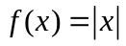 2. 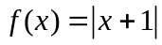 3. 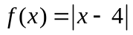

4. 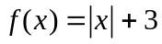 5. 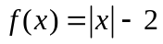 6. 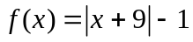

7. 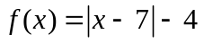 8. 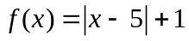 9. 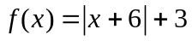

10. 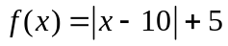 11. 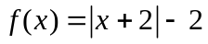 12. 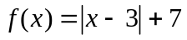

13. 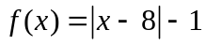 14. 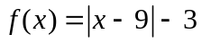

Advanced Algebra Name: _______________________
Worksheet 2.8 day 1 Period: ______

Graph the function.

1. 2. 3.

4. 5. 6.

7. 8. 9.

10. 11. 12.

13. 14.

